# CS 340 Project Two README

## About the Project/Project Title

This project connects the Grazioso Salvare animal database to an easy-to-use dashboard that allows you to view their database and interact with the data.

## Motivation

This project uses the simple Dash framework to allow users to interact with data from a Mongo database.

## Getting Started

To use this project locally, you must have the Grazioso Salvare Mongo database on your system. Change the username and password to your login credentials.

## Usage

### Code Example

Radio buttons on the dashboard allow you to easily filter the animals to what type of rescue you will be looking to conduct.

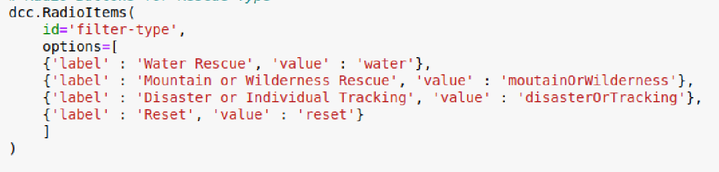

When a radio button is pressed, a MongoDB query is run to filter the data in the data table.

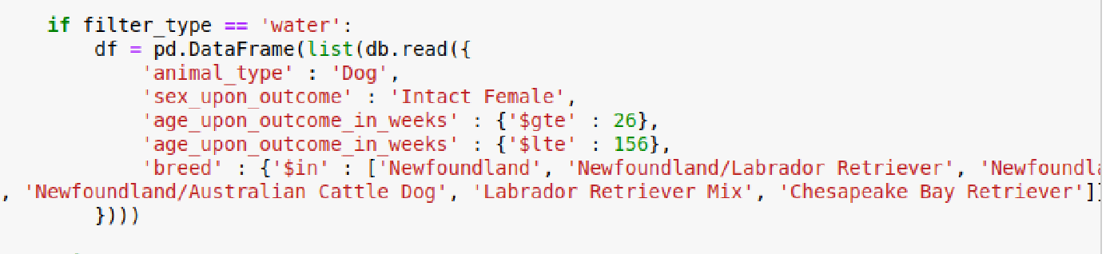

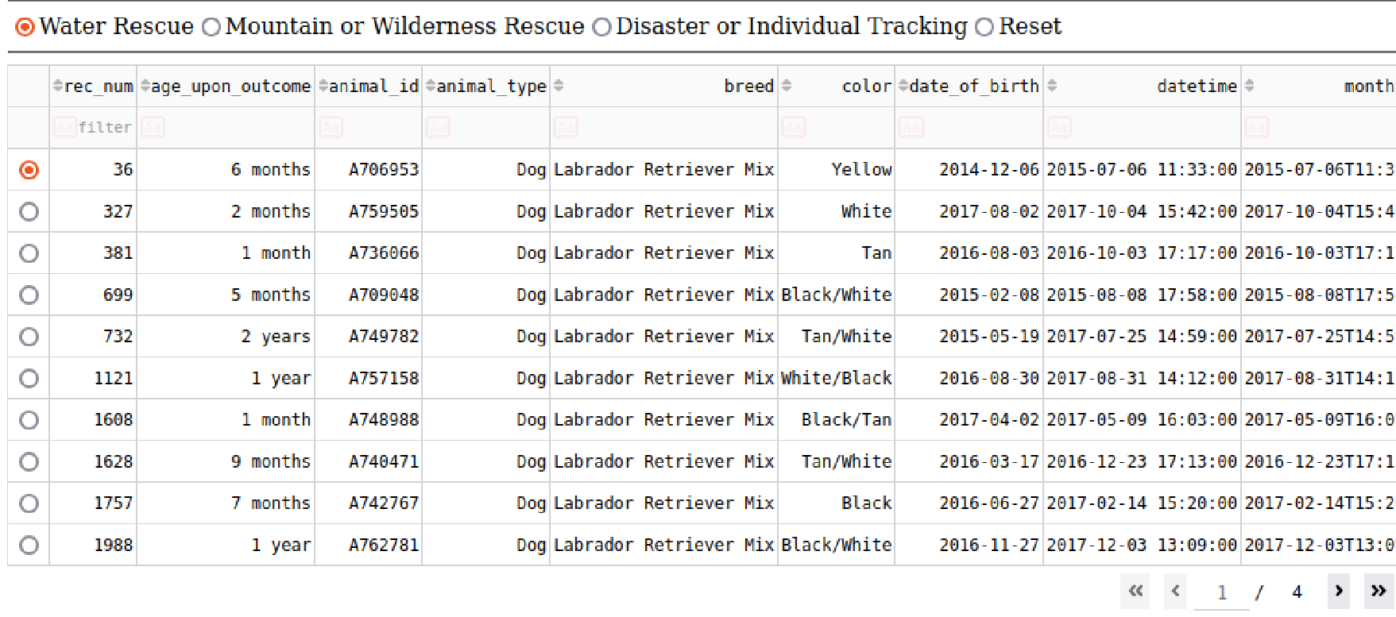

The data table has filter and sorting capabilities. You can click on the top each column and filter or sort the data.



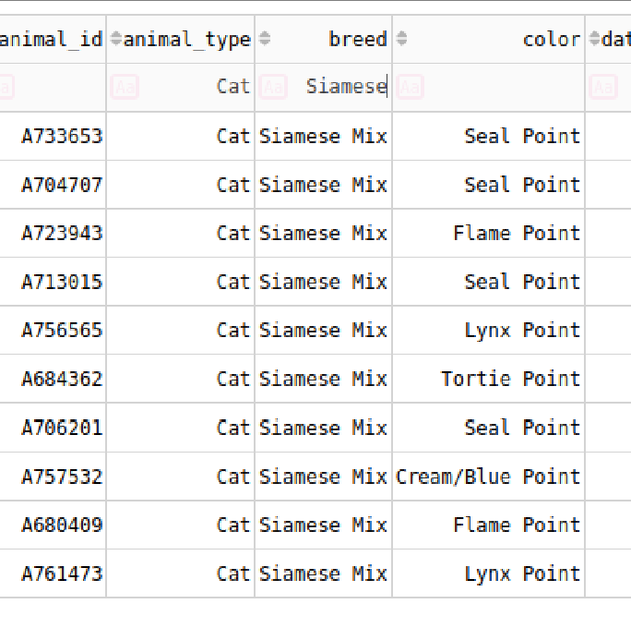

A pie chart is visible on the bottom left of the application. The pie chart updates based on the filters to show the animal’s breeds and percentages.

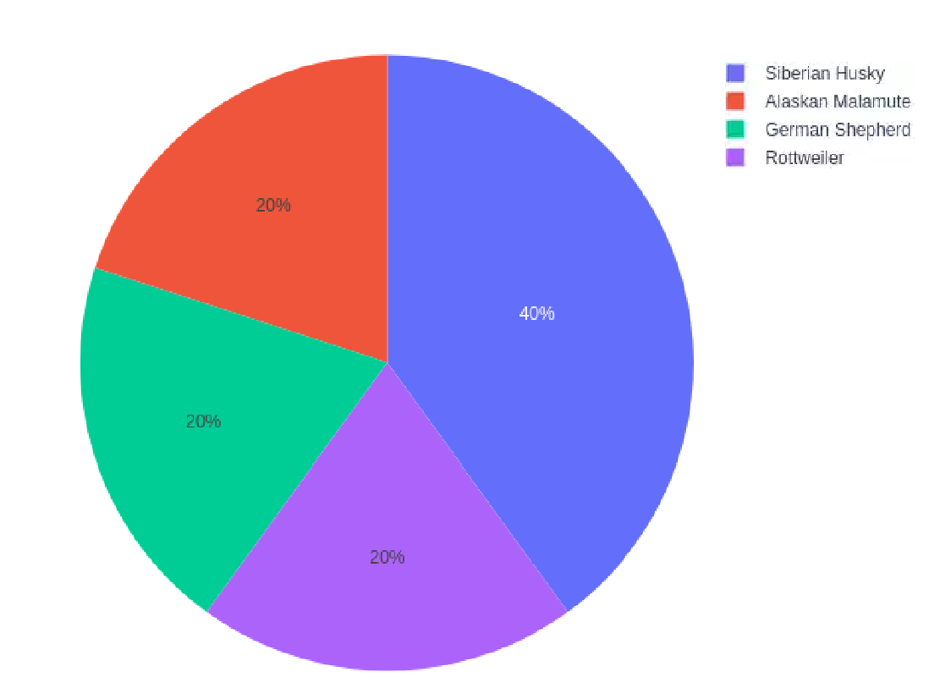

### The bottom right of the application includes a map. The map updates with a pin when an animal is selected to show its location.

### Tests

Test of filtering by querying the database directly.

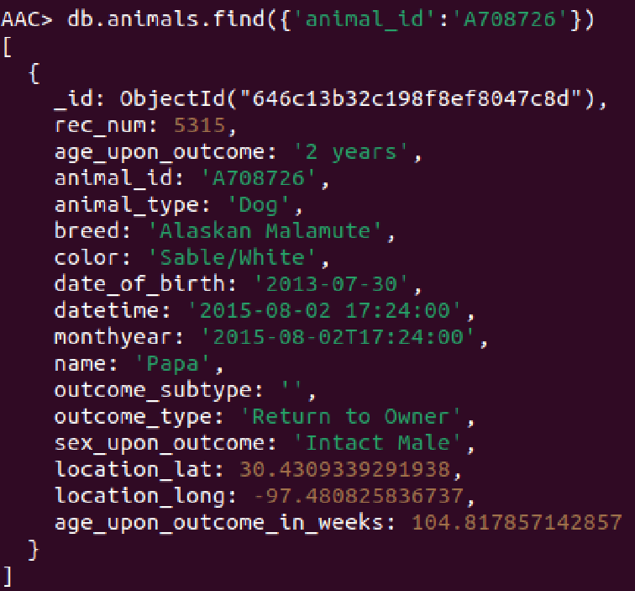



Test Radio button searches by querying the database directly.

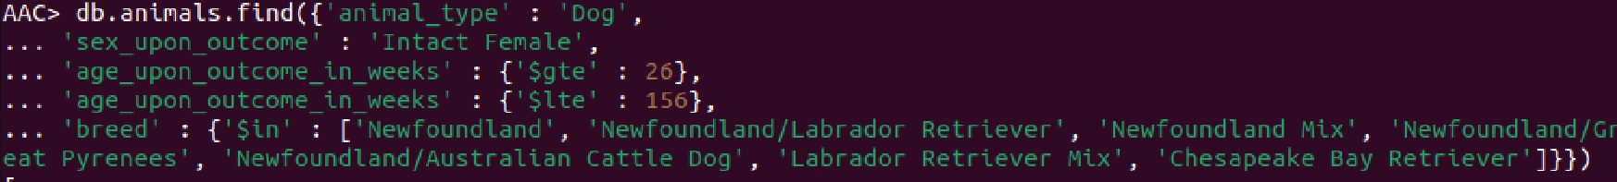

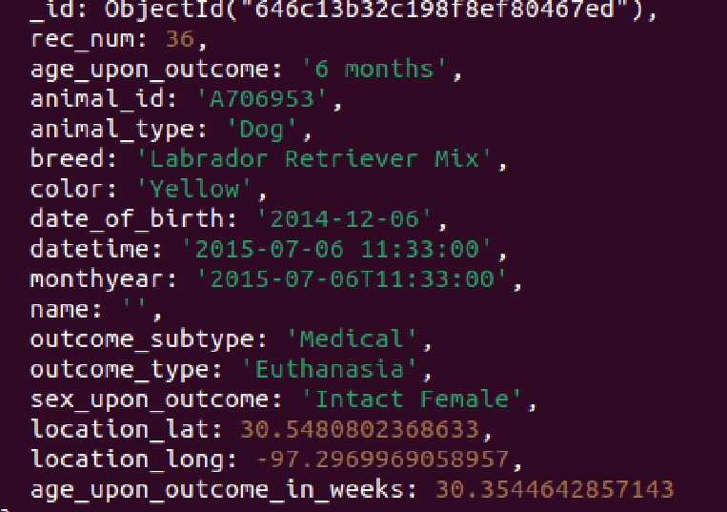

### Screenshots

View of dashboard

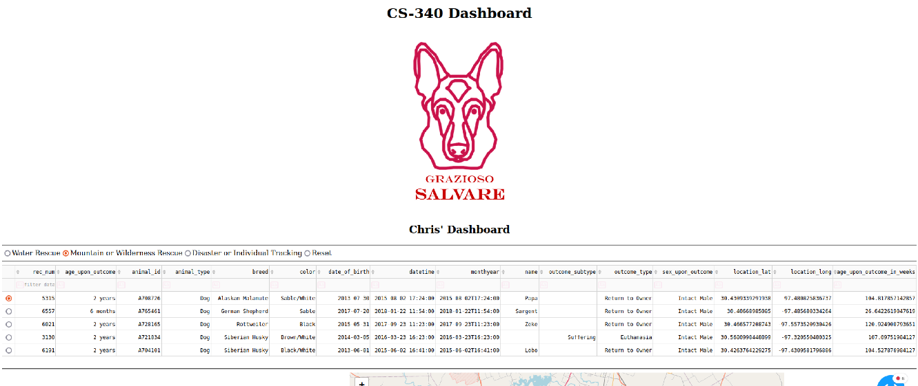

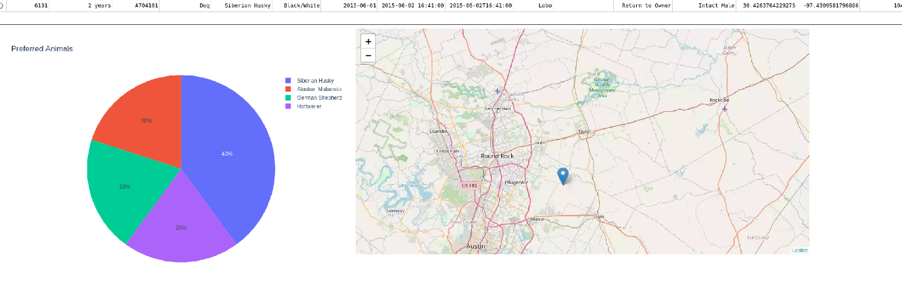

**Feature/System Choices**

MongoDB was used as the main component for development because it is easy to use and easy to interface with Python. The middle layer controller was written in Python due to its simple syntax and ability to easily interact with MongoDB. The Dash framework was used for the user interface. Dash was used because it can be written in Python and requires little coding to create the user interface.

## Contact

Christopher Franklin